Cleaning water bodies using sensors and motors

* **Components** **used**

1) IR sensor

2) L2933D motor driver

3) Basic shield

4) At mega32 microcontroller

5) DC motor

6) LCD

7) Connecting wires

8) USB cable

* **Circuit** **diagram**

**CLEAR PATH**

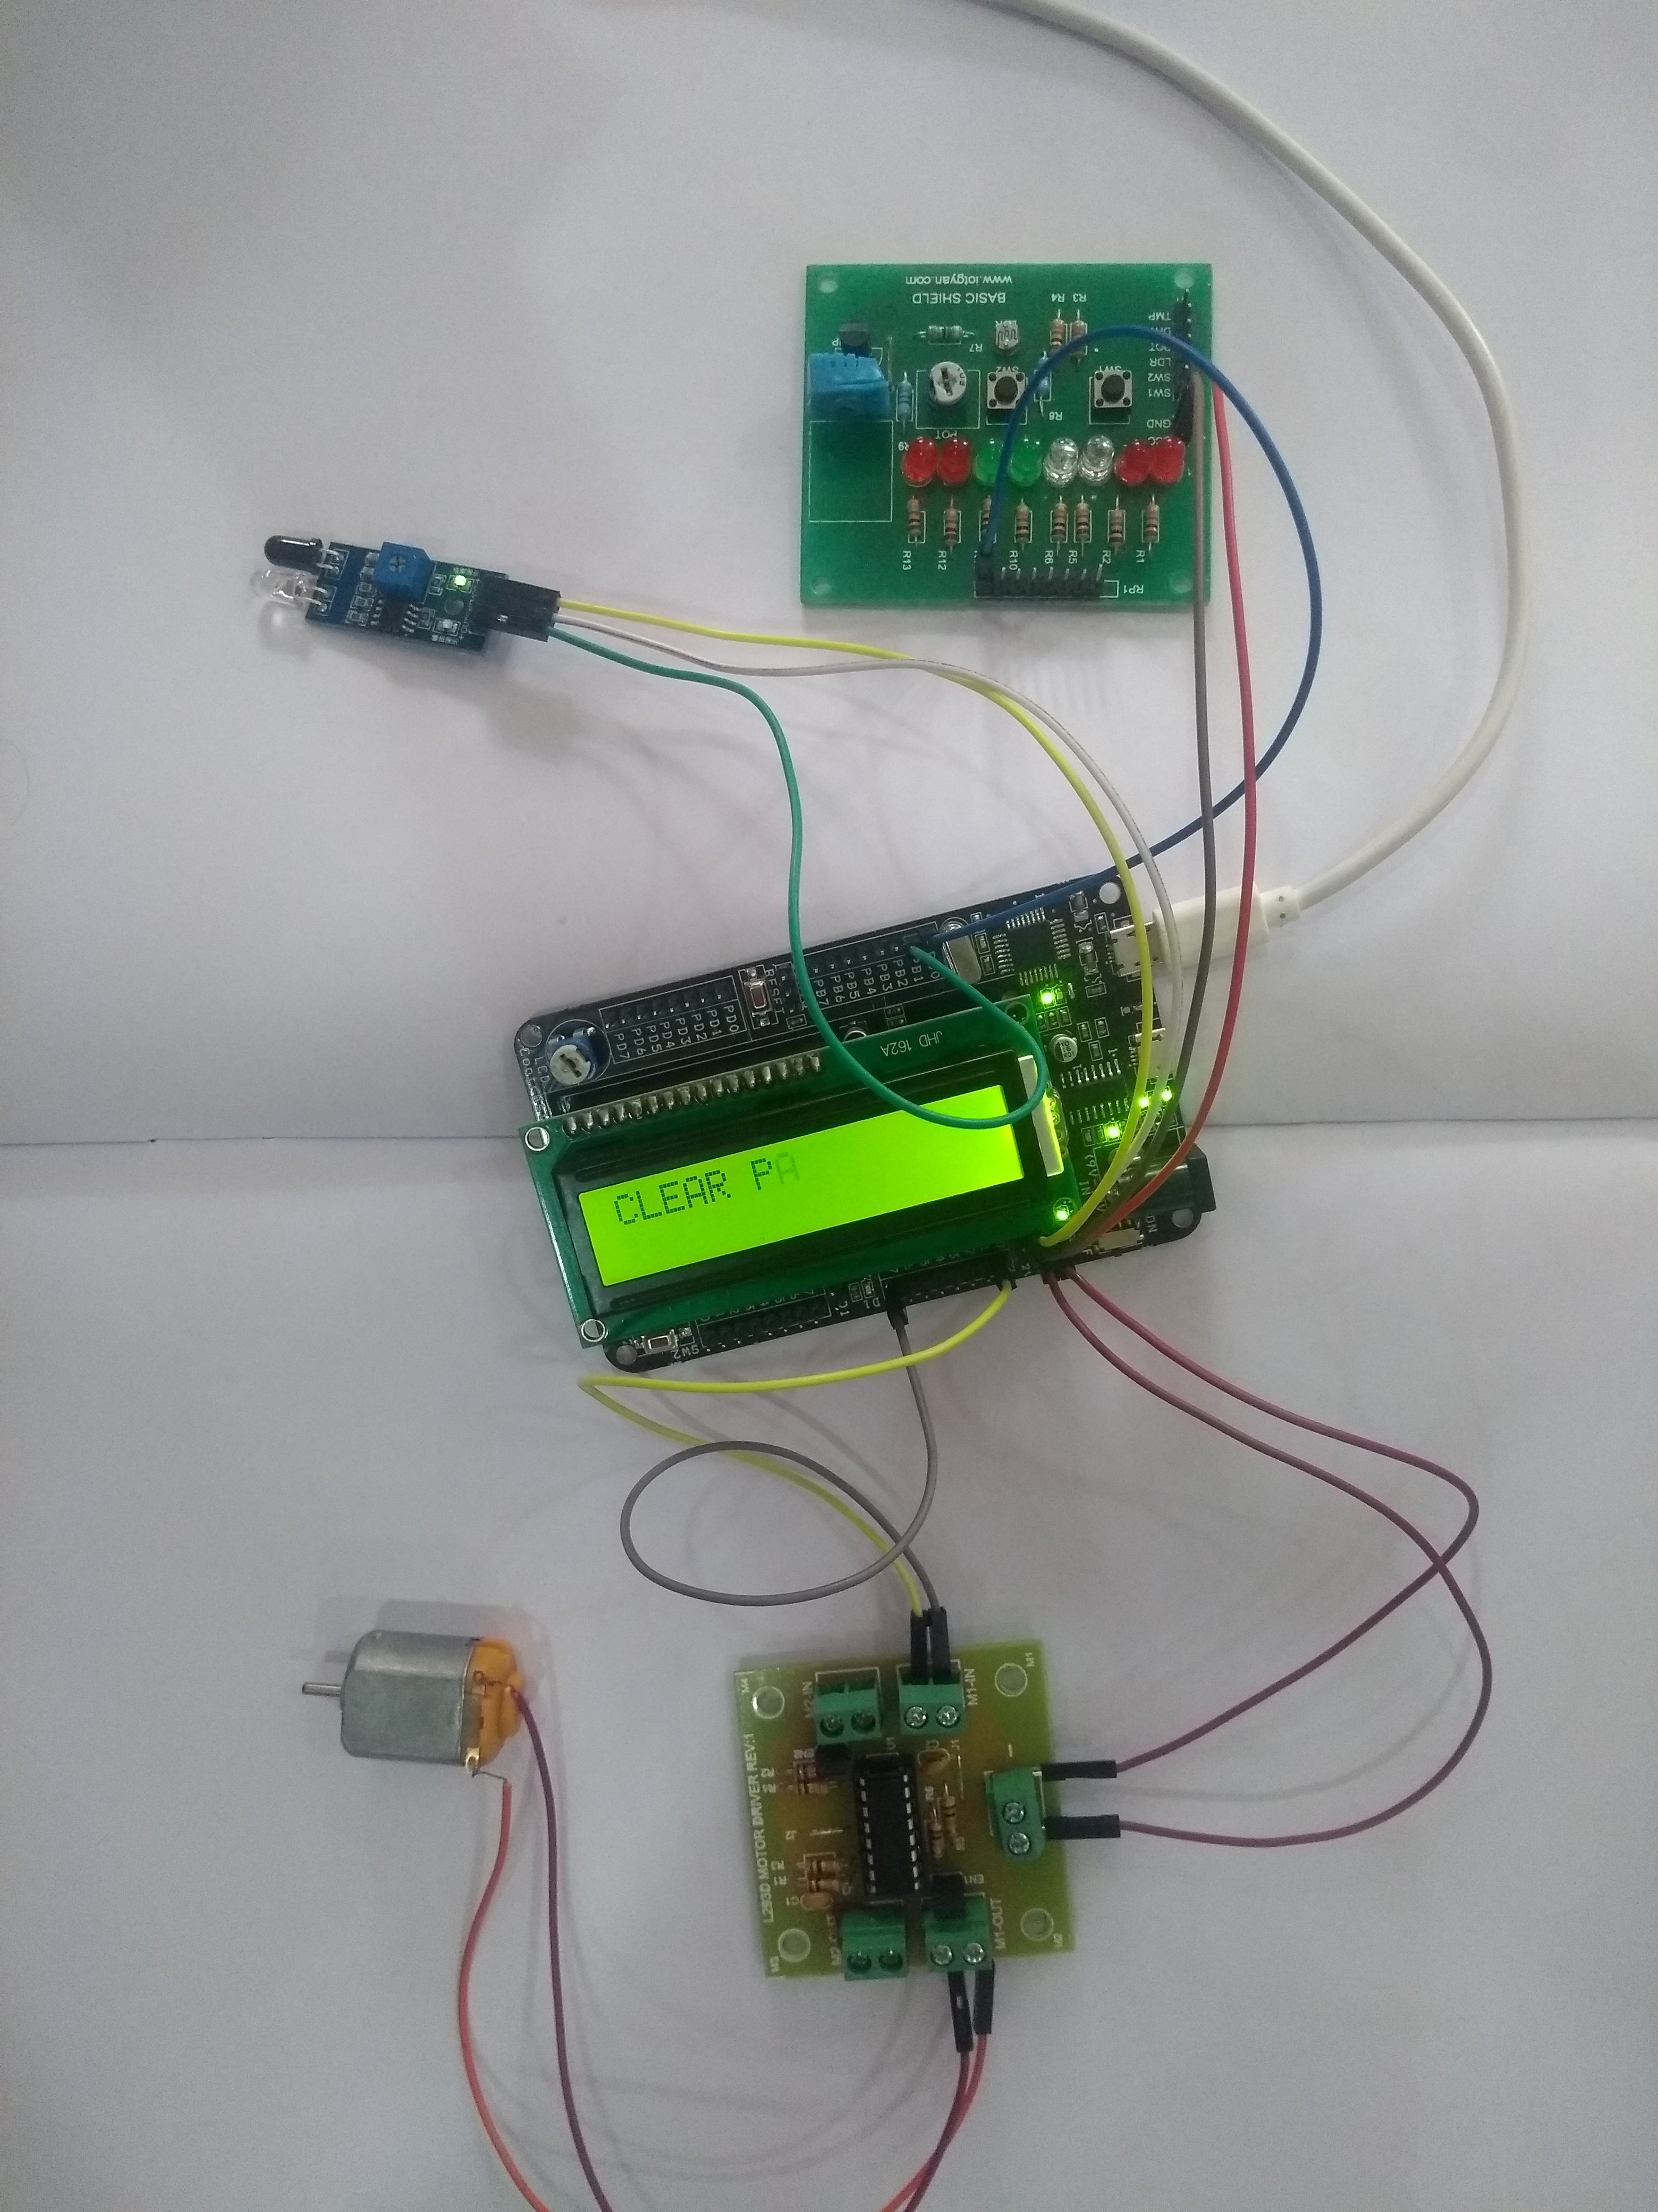

OBJECT DETECTED

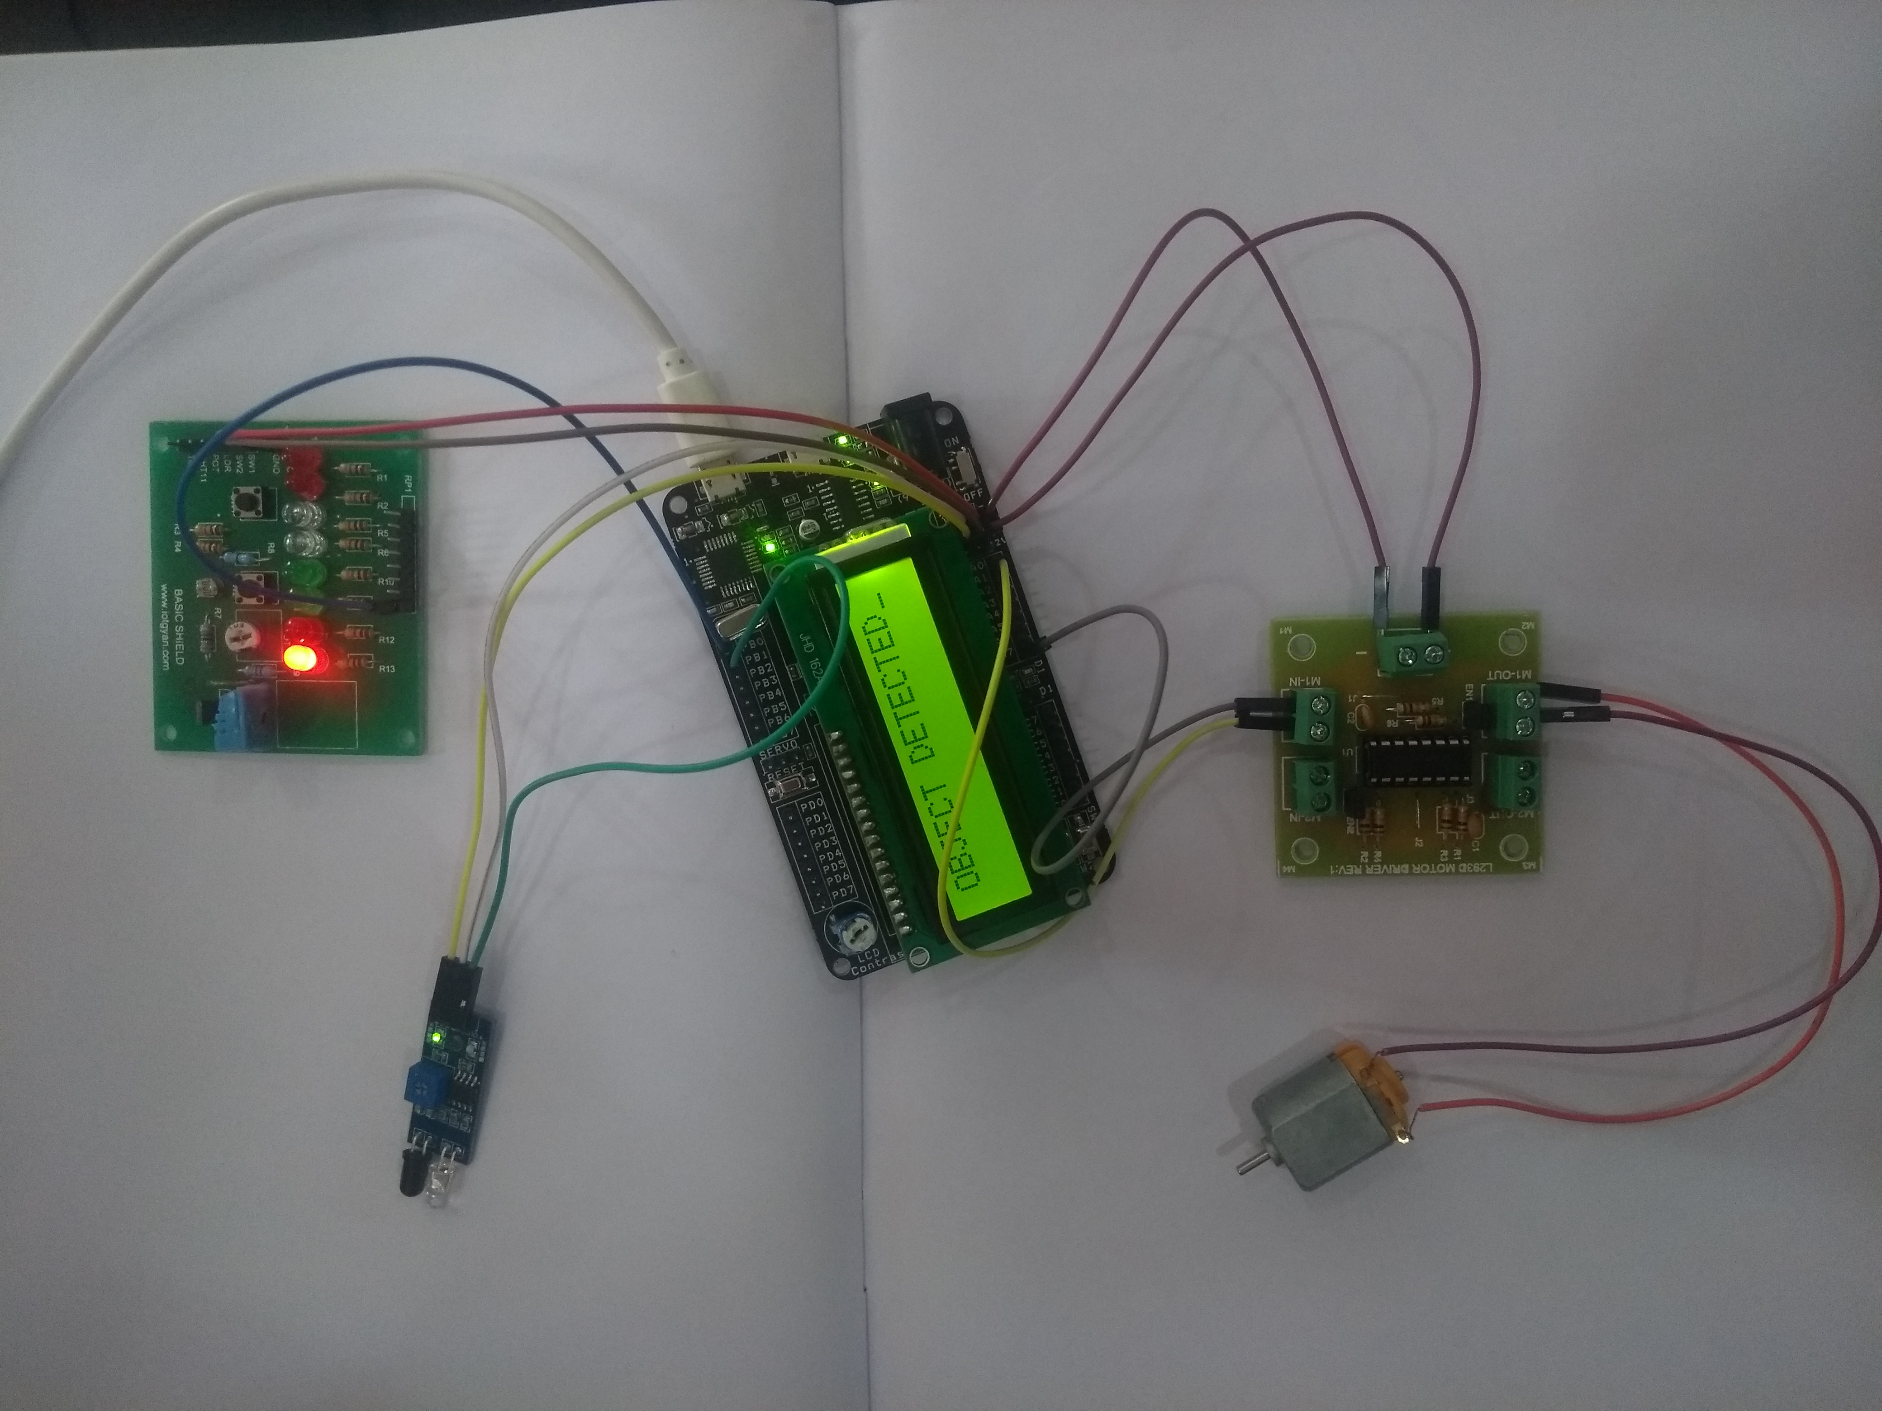

* Real time application of the project

For practical application of this project, the following modifications are to be done:

1. The IR sensor used should be replaced with proximity sensors.

A **proximity sensor** is a sensor which emits a beam of electro magnetic radiation and looks for changes in the return signal.  Different proximity sensor targets demand different sensors.

Our aim in this project is to detect plastic objects and heavy metals. A capacitive proximity sensor is suitable for a plastic target and an inductive proximity sensor is suitable for a metal target.

2) The dc motor should be replaced with servo motor.